PROJECT TITLE:

“CORNWALL’S OPIOID STRATEGY –
THE DEMEDICALISATION OF CHRONIC PAIN”

CHRONIC PAIN – information for clinicians in Cornwall

CONTENTS – click to link

- INTRODUCTION
- ANALGESIC MEDICATIONS
  - Key messages with Dr Keith Mitchell
  - Summary of national guidance
  - Opioids
    - Evidence and risks
    - The opioid trial
    - The opioid management plan and contract
    - Deprescribing and weaning advice
  - Neuropathic pain
  - Other analgesics - paracetamol
- GP QUESTIONS AND ANSWERS
- CORNWALL’S OPIOID STRATEGY – where you fit in
- TIPS FOR GPS
- SKILLS FOR CHALLENGING CONSULTATIONS
- ROLE OF THE PAIN CLINIC
- REFERENCES
- AUTHORSHIP
- A HARROWING CASE REPORT

INTRODUCTION

Audio version here

Hello

My name is Jim Huddy and I’m a GP in Perranporth, Cornwall and I’m the CCG’s clinical lead for chronic pain. I’ve been working with colleagues from secondary care, Drs Keith Mitchell (Consultant in Pain Management), Adrian Flynn (Liaison Psychiatrist) and Paul Fortun (Gastroenterologist) for a couple of years and this is one of our pieces of work.

First, an apology; there is a lot of information in this document however we believe that time spent digesting it will pay back many times over in the future. We’ve done our best to make it easy for you by making audio versions to listen to.

Treating chronic pain in primary care is difficult, time consuming, frustrating and all too often, important positive outcomes for patients are not achieved.

There is a temptation for clinicians to reach for the prescription pad which can lead to ever escalating doses of harmful drugs which is completely understandable because we don’t know what else to offer patients as an alternative and we are somewhat undertrained in this speciality during our career.

NOW WE HAVE A MUCH SAFER AND MORE WHOLESOME ALTERNATIVE:

SELF MANAGEMENT

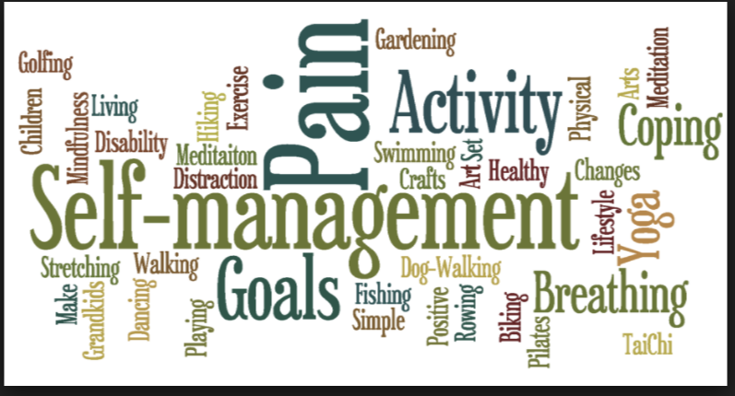

Watch this 5 minute animated clip: here the Australian Pain group explains persistent pain and how a structured approach works best:

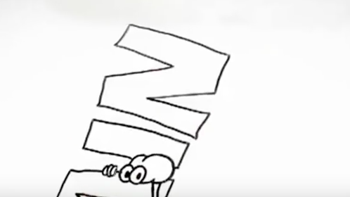
https://www.youtube.com/watch?v=RWMKucuejIs

Understanding and management of chronic pain has undergone dramatic changes in recent years. We now know that after 3-6 months tissue damage is usually healed and persistent pain is more due to maladaptive changes in the pain pathways and the nervous system (especially the spinal cord).

Treating chronic pain is now much more directed at SELF MANAGEMENT where, with the help of re-training of the mind and body, patients learn the skills necessary to perceive their pain differently and in a way that co-exists with a fruitful enjoyable life. This is in contrast to the traditional treatments of the doctor assuming the burden of rendering the patient PAIN FREE using increasing doses of drugs. This approach doesn’t work and often adds to patients’ problems.
To this end, we have written a section for patients, which we believe, will give them all the tools they need to allow many to manage their own chronic pain. We hope that they will then present you, their GP, with a management plan (mind, body, emotions, medications) and you can offer them medical interventions as you see fit.

HOWEVER – for the GP to help the patients, the GPs need to understand the modern meaning of chronic pain and it’s management so it’s crucial that you spend some time familiarising yourself with both the “information for patients” section as well as this “information or clinicians” section, so you can guide them in their recovery. Why not set aside an hour of CPD time to study it? We can assure you, it will be time well spent for future consultations.

Now, in your subsequent consultation, you and your patient will have a much greater understanding of chronic pain and you can discuss the various facets of management, namely
- Patient led self-management
- Pacing, the pain cycle, goal setting, dealing with setbacks
- Physical therapies e.g. physiotherapy, yoga, pilates
- Emotional therapies and coping strategies e.g. mindfulness techniques, meditation
- Drug treatment

Also, as described in later sections, you and your colleagues can instigate drug (especially opioid) deprescribing “change management” projects that will contribute to Cornwall’s Opioid Strategy.

THIS IS HOW IT FEELS TO BE A PATIENT:

This short film is made with actors and convincingly condenses the thoughts of hundreds of patient interviews captured in qualitative studies.

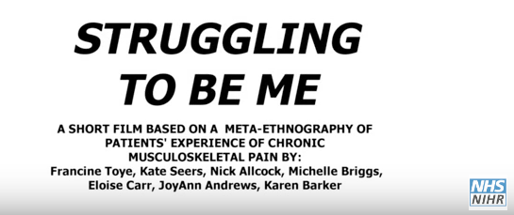
https://www.youtube.com/watch?v=FPpu7dXJFRI

THIS IS HOW IT FEELS TO BE A DOCTOR:

Similarly, this film describes the thoughts of doctors treating patients with chronic pain – you’re not alone!!!

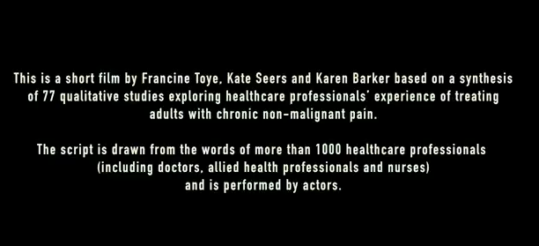
https://www.youtube.com/watch?v=477yTJPg10o

We welcome comments and feedback to jameshuddy@nhs.net

ANALGESIC MEDICATIONS

Audio version here

Key messages

Drugs...

- don’t often help chronic pain and often do harm (especially opioids) for example
  - addiction, overdose, abuse, myocardial infarct, fractures and sexual dysfunction, chronic abdominal complaints and a paradoxical worsening of pain
- should be given on a trial basis and only continued with good objective evidence of improved function (not just pain perception)
- should be reviewed regularly and consider stopping to check they are of benefit

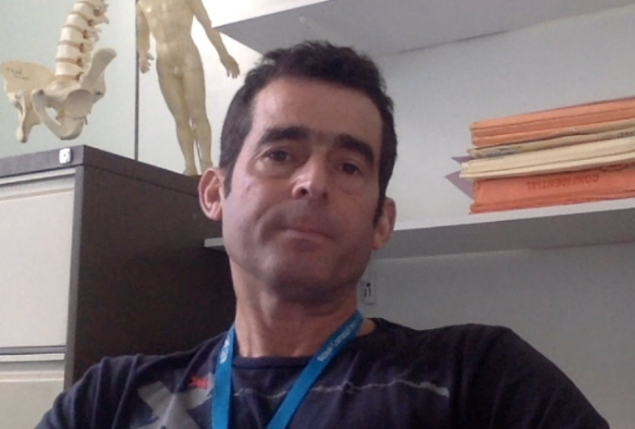

Click here to watch Dr Keith Mitchell talk about analgesics in chronic pain
https://youtu.be/CdpM93uq5Zk

Some drugs help some people with chronic pain some of the time however expectations should be low - 95% of patients with chronic pain will still be in chronic pain in 5 years time.

Also there are significant risks, especially with opioids, of drug tolerance and addiction and even overdose and death in this vulnerable group of patients.

BEFORE PRESCRIBING please ask the patient to work through the “information for patients” section – we hope that once they have worked through the resources they will have a good understanding of self-management and together you can work out where medical treatments fit in.

Remember, the mantra behind this project is “the demedicalisation of chronic pain”. Cornwall is in about the 70th centile for prescribing of analgesics and we need to reduce that – responsibly and compassionately. You can help.

If we do start an analgesic we don’t just start it long term. We explain realistic expectations of benefit and risk, sometimes with written information (see opioid section below) for patients to take away and consider. Patients should have informed consent. Then we give a TRIAL of treatment for a few weeks at a decent dose (the regimen depends on the drug of course).

After the trial you must be satisfied of a SIGNIFICANT IMPROVEMENT not just in subjective pain levels but in OBJECTIVE MEASURES OF IMPROVED FUNCTION AND ACTIVITIES. If you are not satisfied then the trial has failed and you should discontinue that medication.

ALSO, it is good medical practice to intermittently have a drug holiday to ensure that the benefit persists. You could build that into your electronic prescribing algorithm.

This advice is backed up by strong evidence from the Faculty of Pain Medicine.

SUMMARY OF NATIONAL GUIDANCE

NB some advice is conflicting e.g. strong opioids for chronic back pain

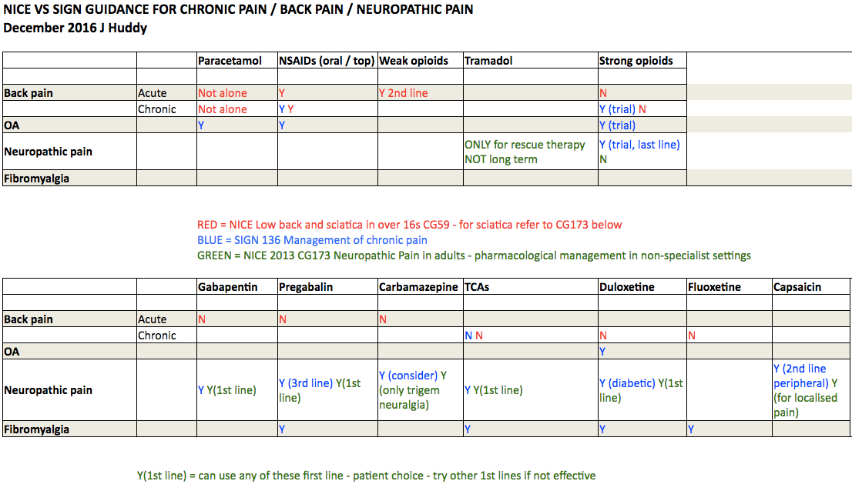

References:

NICE guideline [NG59] Low back pain and sciatica in over 16s: assessment and management Published date: November 2016

NICE guideline [CG173] Neuropathic pain in adults: pharmacological management in non-specialist settings Published date: November 2013

SIGN guidance 156 – Management of Chronic Pain Published date December 2013

OPIOIDS

Audio version here

Evidence and risks

Opioids have been around for thousands of years. While they have a robust benefit and evidence base in the treatment of acute pain and in pain due to cancer, the evidence for SUSTAINED benefit in chronic non-cancer pain IS LACKING. Most of the trials are of short duration, sponsored by the pharmaceutical industry and of flawed methodologies.

Prescription rates are rising (16m scripts in the UK in 2015 = £200m) and the drugs are generally ineffective, harmful, addictive and difficult to stop.

THERE ARE NO TRIALS LONGER THAN 12 WEEKS DURATION SHOWING SUSTAINED BENEFIT HOWEVER THERE ARE WELL RECOGNISED RISKS AND HARMS

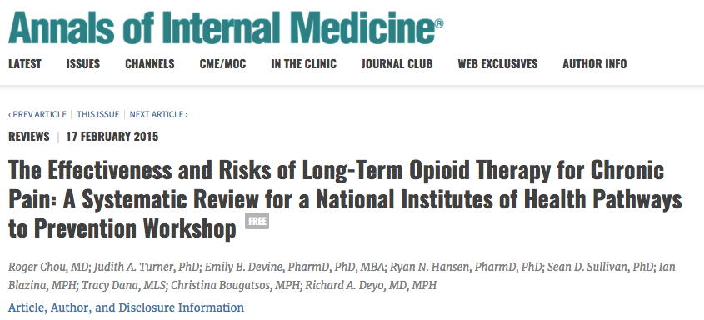

Conclusion:
“Evidence is insufficient to determine the effectiveness of long-term opioid therapy for improving chronic pain and function. Evidence supports a dose-dependent risk for serious harms”

http://annals.org/aim/article/2089370/effectiveness-risks-long-term-opioid-therapy-chronic-pain-systematic-review

Having said that, opioids will benefit a SMALL NUMBER OF PATIENTS WITH CHRONIC PAIN - long term AND with improved function (estimates state that about 1 in 5 patients will have, at most, a 30% reduction in pain). Moreover, they might not become tolerant, dependent or addicted to the drugs and their usage is completely responsible. We must be careful not to deny these patients drugs that really help them.

However, this is unusual. In the 1990s we were told that with increasing doses patients can be rendered PAIN FREE and there is LOW RISK OF ADDICTION – THESE MESSAGES ARE JUST PLAIN WRONG!

If you have a vulnerable patient who suffers in most avenues of their lives and you prescribe them a psychoactive drug which, to start with, helps their physical pain and also gives them a mild euphoric effect (the “warm hug”); before long, when you ask the question “is this helping your pain” you will receive the answer “yes” (it helps emotional pain short term).

This doesn’t mean that continuing to prescribe opioids is good medicine. There is a fine line between “is this helping your pain?” and “does this give you a temporary dissociation from your difficult life and numb unpleasant emotions?”. As time passes the question could be “do these drugs relieve that very unpleasant feeling you get when you don’t have your pills?” and at that point the patient and the prescriber are in trouble.

Bear in mind that the USA is suffering it’s worst drug addiction epidemic ever with annual deaths from opioid drugs in the region of 50,000 (more than car accidents and gun crimes combined) and a large proportion are due to prescribed medications.

PLEASE BE CAREFUL BOTH FOR YOUR PATIENTS AND YOURSELF

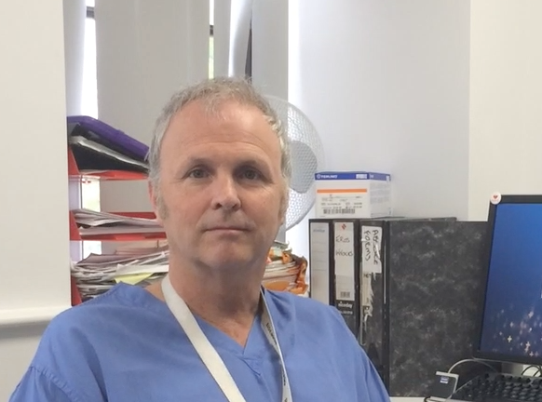

Watch Dr Paul Fortun talk about the dangers of opioids
https://youtu.be/tA6yK40lsiw

THE OPIOID TRIAL

Audio version here

BEFORE PRESCRIBING please ask the patient to work through the “information for patients” section that we have written. Hopefully this will allow them to formulate a self management plan and you can look at it together. Then you can consider whether drugs might have a useful role.

If you’re thinking of prescribing opioids please give the patient our “OPIOID MANAGEMENT PLAN AND CONTRACT” (next section) to take home and read - you might find that they don’t want to try these drugs.

If you embark on a trial of opioids (even weak ones)
- consider using our OPIOID MANAGEMENT PLAN AND CONTRACT (next section) and make sure the patient has read and absorbed the information about the potential risks.
- prescribe a decent dose e.g. for morphine - 30mg per day (either oramorph or MST) when in or when anticipating pain, for a few weeks
- then have a detailed review

You must be satisfied of a SIGNIFICANT IMPROVEMENT not just in subjective pain levels but also in OBJECTIVE MEASURES OF IMPROVED FUNCTION AND ACTIVITIES. If you are not satisfied then the trial has failed and you can keep that door well and firmly closed. Have firm boundaries with a consistent message from all your colleagues.

REVIEW REGULARLY to start with – every week or two (maybe by phone?)

If the TRIAL IS SUCCESSFUL
- for longer term prescribing - use intermittent drug holidays to ensure that function is improved on the drug
- Switch to a slow release formula to mitigate aberrant drug use behavior from immediate release substances e.g. zomorph bd

DO NOT EXCEED 120mg OF ORAL MORPHINE EQUIVALENTS PER DAY (Google “OPIOID CONVERSION” to translate drugs and doses) BECAUSE OVER THIS DOSE RISKS DEFINITELY EXCEED BENEFIT – usually much lower doses are used.

Regular reviews are mandatory, never longer than 6 month intervals to discuss ongoing benefit, adverse effects or signs of aberrant drug use behaviour with a view to STOPPING the opioids if benefits are not outweighing the risks . This is easier for the prescriber if there is a signed opioid contract as above.

STOPPING and weaning opioids is a skilled process and advice is included for patients and prescribers in the opioid section

This is what the“opioids aware” section of the Faculty of Pain Medicine website has to say:

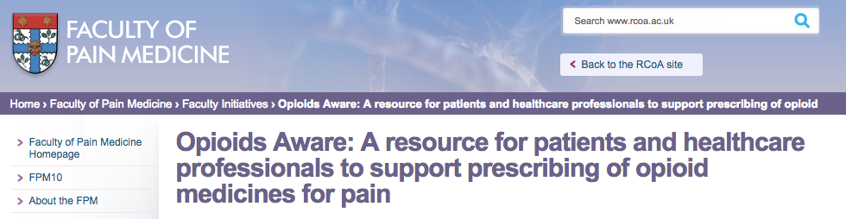

1. Opioids are very good analgesics for acute pain and for pain at the end of life but there is very little evidence that they are helpful for long term pain

2. A small proportion of people may obtain good pain relief with opioids in the long-term if the dose can be kept low and especially if their use is intermittent. However it is difficult to identify these people at the point of opioid initiation

3. The risk of harm increases substantially and there is no increased benefit at doses above an oral morphine equivalent of 120mg / day

4. If a patient is using opioids but is still in pain, the opioids are not effective and should be discontinued, even if no other treatment is available

5. Chronic pain is very complex and if patients have refractory and disabling symptoms, particularly if they are on a high opioid doses , a very detailed assessment of the many emotional influence on their pain is essential [usually via the pain clinic]

OPIOID MANAGEMENT PLAN AND CONTRACT

We have written an “Opioid Management Plan and Contract” which you can download below.

The aim of this document bundle is for patients to have a clear understanding of the possible benefits and the potential pitfalls of long-term opioid usage. We suggest you give them the entire bundle to read and consider BEFORE embarking on an opioid trial.

It can be scanned into the electronic patient record. There are 3 parts:

Part 1 - Opioids for Pain Management – Patient information leaflets describe what opioid analgesics are, when they are used, realistic expectations of benefit and details of the significant risks associated with long term use.

Part 2 - Weaning Opioids – Advice for patients gives tips on how to tell if the drugs are working and if not, how to get off these potentially addictive medications

Part 3 - Opioid Management Plan - Treatment Agreement. This is signed by the patient and prescriber. It outlines terms and conditions to be satisfied for opioid treatment to continue. The clinician provides a brief clinical summary plus details of present analgesic use and suggestions for the future. If new drugs are started it will describe dose ranges that should not be exceeded. It will also give advice on when to try reducing the dose and how to achieve discontinuation if possible.

Download it HERE

WEANING OPIOIDS – ADVICE FOR PRESCRIBERS

Audio version here

Key messages

- Ensure patients have access to the “information for patients” section that we have written to give them alternative strategies for managing their pain – there is a section in there about weaning opioids
- Prioritise those on more than 120mg oral morphine equivalents per day – this is hazardous prescribing
- Go slowly
- Expect pain to worsen during the weaning process but it should settle
- Deprescribing opioids in primary care is an evidence free zone – please let us know how you get on
- For clinical advice backup contact the pain team
  - keith.mitchell4@nhs.net

A drug wean should be considered a one-way process. Pick a target opioid dose. This may be zero. It may be a dose that you and the patient can agree upon as a reasonable, achievable dose. For patients on very high doses, the “generally accepted maximum” of 120mg Oral Morphine Equivalents (that’s about 37mcg/hr fentanyl) might be appropriate. A wean can be paused but should not be reversed except in exceptional circumstances.

METHODS: This advice reflects standard advice from the CDC and Faculty of Pain Medicine

Find the nearest dose that you can to 10% of the patient’s daily opioid intake, and reduce by that every 2 weeks. The reduction becomes a larger proportion of the dose that the patient is taking as their dose reduces. This is why patients may run into difficulty as they reach lower doses. Explain, encourage and if necessary, slow down!

Simple ways of reducing by 10% include the use of zomorph 10mg tablets, or appropriate volumes of oramorph.

There are a variety of weaning strategies published. Feel free to vary from the above if the patient requests or if you consider it appropriate. A much faster wean is tolerated by many, who may want to get it over with.

Example:

Patient has a 50mcg/h fentanyl patch

This is the oral morphine equivalent of 200mg per day (Google “opioid conversion”).
Convert Fentanyl to zomorph 200mg per day (100mg bd)
Then reduce by 10% = 20mg per day reduction hence prescribe zomorph 90mg bd for 2 weeks
Reduce by 20mg every every 2 weeks hence 80mg bd then 70mg bd etc
Continue until target dose is reached.

To wean or not to wean?

Factors in deciding whether to wean opioids, and how far to reduce the dose, include:
- Patient choice
- Shared decision between patient and prescriber
- Evidence that opioids are not helping
  - Patient complaints of pain
  - Patient’s function is poor as reported by patient’s family or associates
- Risk of side effects or complications of opioids
- Risk of drug theft or diversion
- Patient’s ability to cope with the effects of dose reduction
- Risk of patient procuring more dangerous opioids from alternative sources

Other considerations before starting a wean:

Encourage patient preparations. These include timing of weaning steps, distraction strategies, social support, help in reducing temptation to relapse – signpost patients to the “information for patients” section that we’ve written
Consider and agree GP or other healthcare support and monitoring during the wean.

What if the patient isn’t keen?

GMC guidance is that doctors have to act in patient’s best interests – this may involve reducing an opiate script against their wishes.
Document your reasons for embarking on an enforced wean, and on your attempts to gain patient agreement. A documented MDT discussion is advisable. Consider contacting secondary care (such as the pain clinic) for advice.

A suggested strategy for an enforced wean:
Pick a reduction dose (eg 10%)
Inform the patient that you will reduce their prescription by that amount every month. They can decide at what point during the month they wish to reduce their intake, but need to be ready for the lower dose when they collect their repeat
Make sure you implement the dose reductions!
You will need to ensure that the patient is not inadvertently prescribed opioids by colleagues by appropriate communication within the practice, with locum services and if necessary emergency services.

Sources of assistance

At the time of writing there is a lot of talk about how to support patients during opioid deprescribing, ideally using an MDT approach. Sadly however, these services are not yet in existence.

ADDACTION may be helpful in providing a key-worker, group work or additional information though, of course, patients may be upset by the stigma associated. Patient have to agree to the referral and be in need of additional psychological support.

Pharmacological assistance

Drugs given to assist weaning can themselves be weaned after each step reduction in opioid, or maintained throughout the weaning period.

- Clonidine (adrenergic α2 agonist) 100mcg 6° prn may lessen anxiety, sweats and chills.
- Lofexidine 200mcg 6° prn (then titrated prn) - similar to clonidine; may cause less hypotension
- Gabapentin 300mg tds may reduce anxiety and pains
  - Both Clonidine and Gabapentin should be started and reduced gradually, by a tablet every 2 days
- Diazepam 2mg tds for agitation
- Loperamide 2mg may reduce diarrhea
- Buscopan – 10mg tds for abdominal cramps
- Quinine 200mg 12° prn for generalized cramps
- Paracetamol or NSAIDS (eg ibuprofen) may reduce muscle and joint pains

Dr Keith Mitchell
Consultant in Pain Medicine
Royal Cornwall Hospital
2017

NEUROPATHIC PAIN

Audio version here

Whereas nociceptive pain is due to tissue damage stimulating pain receptors, neuropathic pain is due to direct damage or irritation to the peripheral or central pain fibres themselves. Neuropathic pain has typical features, being described as burning, tingling, electric, stabbing, unrelenting and independent of activity. Also look for allodynia and hyperaesthesia.

Typical treatment options for neuropathic pain are tricyclic antidepressants, gabapentinoids and duloxetine

NICE guidance states that you choose any one first line then any one second line then any one third line etc depending on the patient, e.g. if sleep is poor amitriptyline would be good, alternatively with co-existant depression then duloxetine for example.

Remember that
- Pregabalin (Lyrica) is expensive
  - 100mg 84-cap pack = £96.60 BNF
  - amitriptyline, gabapentin and duloxetine are much cheaper
- Gabapentin and pregabalin are used as street drugs

Neuropathic Pain Medications – Common Features

- Neuropathic Pain medications provide little instant pain relief
- They are best used regularly, “by the clock”
- When taken in this way, pain relief increases gradually over time.
- The have effects other than pain relief, both positive and negative
  - These also change over time
  - Side effects may diminish with ongoing use
  - The possible positive effects may inform which medication is trialled first

Overall, the pain-relieving effects of these medications are not great in neuropathic pain, and even weaker in somatic pain conditions, though they may benefit either.

For these reasons, a standard approach to trialling these medications is
- Prescribe the drug, but do not activate repeat prescription
- Titrate dose as appropriate
- Put up with side effects in the hope that they will diminish
- After 2-4 weeks on final dose, review the patient and ask them “Overall, has my quality of life gone up since I started these drugs?”
- If the answer is clearly “Yes”, continue the medication, reviewing the continuing need for the medication every 6-12 months
If the answer is not clearly yes, wean and discontinue the medication.

Tricyclic Antidepressants (TCA’s)
- Amitriptyline has the best evidence
  - If this causes excessive sedation, consider CLOMIPRAMINE or IMIPRAMINE, which sedate for shorter periods, or NORTRIPYLINE which is less sedating though much more expensive.

Possible additional benefits include improved sleep and, at higher doses, improved mood. Avoid in tachydysrhythmias, glaucoma or significant prostatism. Warn about dry mouth and constipation.

Gabapentinoids
There is little difference between gabapentin and pregabalin in clinical benefit, and a large difference in cost. Possible additional benefits include anxiolysis and improved sleep. Warn about wide range of potential side effects.

Duloxetine
The possible additional benefit is mood improvement. It’s also cheap.

See the beginning of this section for the tabulated summary of NICE and SIGN guidance of indications

TRICYCLIC ANTIDEPRESSANTS

https://www.britishpainsociety.org/static/uploads/resources/files/FPM_Amitriptyline.pdf

https://www.britishpainsociety.org/static/uploads/resources/files/FPM-Nortriptyline_0.pdf

GABAPENTINOIDS

https://www.britishpainsociety.org/static/uploads/resources/files/FPM-Gabapentin_0.pdf

https://www.britishpainsociety.org/static/uploads/resources/files/FPM-Pregablin_2.pdf

DULOXETINE

https://www.britishpainsociety.org/static/uploads/resources/files/FPM-Duloxetine_0.pdf
OTHER ANALGESICS

PARACETAMOL

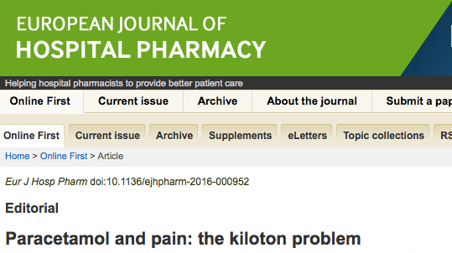

Dr R Andrew Moore, Pain Research, Nuffield Division of Anaesthetics, University of Oxford
Eur J Hosp Pharm doi:10.1136/ejhpharm-2016-000952

Latest evidence suggests paracetamol is neither as effective nor as safe as we thought.

Here are the highlights of this editorial:

LACK OF EFFECTIVENESS

- at doses between 500 and 1000 mg is in the least effective quartile of drugs for treating acute postoperative pain
- Paracetamol 1000 mg has modest efficacy in migraine and tension-type headache
- at doses up to 4000 mg daily is ineffective in back pain
- at doses up to 4000 mg daily is practically ineffective in arthritis. Though marginally better than placebo, paracetamol has little chance of achieving clinically meaningful benefit in osteoarthritis
- No review evidence that paracetamol works for dysmenorrhoea, neck pain, rheumatoid arthritis or cancer pain
- For chronic pain we have evidence of absence of any clinically useful effect of paracetamol, either alone or in combination, and at doses of up to 4000 mg daily.

LACK OF SAFETY

- Increased mortality, cardiovascular adverse events, gastrointestinal adverse events and estimated glomerular filtration rate decrease of at least 30 mL/min/1.73 sq m
- Acute liver failure was twice as common in non-overdose paracetamol-exposed patients than with NSAIDs in a large case-population study
- In clinical trials in chronic pain, patients taking paracetamol were four times more likely to have abnormal results on liver function tests than those taking placebo
- Paracetamol had very similar adverse event rates to ibuprofen over 3 months in patients with arthritis and was not better tolerated than ibuprofen for short-term relief of common pain
- Reports of patients with any adverse event in acute pain studies were the same for paracetamol (up to 1000 mg) and placebo

GP QUESTIONS AND ANSWERS

Audio version here

“So what is a GP’s role in pain management if the patient is self-managing their condition?”

- Signposting the patients to the “information for patients” section that we’ve written.

- Obviously you, as the prescriber, need to be familiar with the different medications that can be tried in chronic pain management but remember that drugs are only a small piece in the management jigsaw.

- You may feel it appropriate to refer patients to physiotherapists or counsellors or any other social prescribing that may be available in your area.

- You should arrange regular reviews to assess response (or lack of it) to medications and also review treatment goals and achievements.

- Be aware of the role of the pain clinic and refer if necessary (see later)

How do I deal with chronic pain in a 10 minute consultation?

You can’t! In this video clip Dr Tim Williams (GPSI in community pain management) explains his strategy to assess and manage chronic pain patients within the confines of hectic modern general practice.

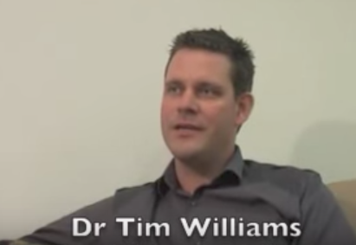
https://www.youtube.com/watch?v=FMBP2XWVEec

How do I diagnose chronic pain? And what if I’m missing something?

Chronic pain is a clinical diagnosis. Consider it when pain lasts longer than 3 months after tissue damage (when we would have expected pain to fade) and bear in mind there doesn’t need to be tissue damage at onset. It might have an ongoing cause (e.g. OA), it might not (e.g. fibromyalgia and other “functional” or “medically unexplained” syndromes) or it might have started with an acute injury that’s healed (e.g. complex regional pain syndrome from an ankle injury).

Making the diagnosis is challenging and GPs are in a good position because they have the right skills (pragmatism, balancing uncertainty, good communication and long term Dr-patient relationship, trust) plus good knowledge of the patient’s physical and emotional health plus the social context.

Often we worry that we’re missing an important elusive diagnosis which when diagnosed and treated will relieve all the suffering. True, this sometimes happens but it is very rare. Much more likely is that persistent testing and retesting reinforces the “elusive diagnosis” belief. This hampers the journey to acceptance.

There’s no reason to not introduce chronic pain concepts ALONGSIDE other investigations and treatments. As time goes on we tend to swap focus from the elusive diagnosis and towards symptom management. Patients can find this difficult to accept so good communication skills are important here.

Why does confidently diagnosing chronic pain help the patients?

The normal-test-after-normal-test approach with a ever growing list of diagnoses that the patient HASN’T got makes their condition worse because we falsely lead patients to believe their chronic pain is secondary to a treatable / curable underlying condition – hence encouraging denial of the diagnosis of chronic pain.
Making a confident diagnosis of chronic pain AS A STAND ALONE CONDITION (with or without a co-existing biological diagnosis) helps patients know where they stand for now and for the future and allows them to accept a life alongside their pain and get on with self-management.

If it’s a stand-alone condition – why can’t we treat it as a stand-alone condition ALONGSIDE other diagnoses? For example, if someone’s got chronic pancreatitis and they get persistent abdominal pain, can I use these techniques alongside gastroenterological treatments?

Good question – there is no reason why you can’t teat chronic pain alongside tests or treatments for other conditions

A lot of this is sounding very similar to other conditions like chronic fatigue syndrome, fibromyalgia and IBS – can I use the same principles and resources with these diseases?
Yes

What’s the role of medication in self-management of chronic pain?

We are told that we both over-treat and that we under-treat pain – how does that work? What it means is that there are SOME (but not many) patients who will get benefit (meaning improved work or leisure functions) from drug therapy but that number is small so we have to get the right patients on the right drugs BUT not over-treat those who don’t benefit or who misuse the medications.

95% of chronic pain patients will still have pain in 5 years so aiming to be PAIN FREE is an unrealistic goal. We have over-emphasised the role of medication in the past. Some drugs can help some people but make sure they are given on a TRIAL BASIS and STOPPED if there is not significant improvement in FUNCTION. There’s much more information on medications later...

In this short video Dr Nick Plunkett, Consultant in Pain management at Sheffield Teaching hospitals - talks about medications as a ADJUNCT to self-management and warns of the risks of long term higher dose strong opioids

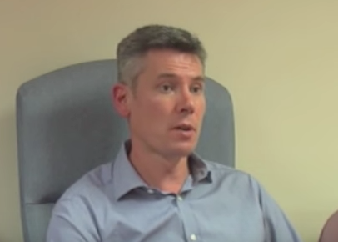
https://www.youtube.com/watch?v=mPzWbbisJVg

My patient has read the patient section of your website and come to me with a list of requests – I feel disempowered and threatened! What do I do?

Enjoy the experience! For years we’ve not known what to do for our patients with chronic pain. Now we do. So as long as you believe the requests are medically reasonable, go for it!

If you do NOT believe the requests to be medically reasonable e.g. increasing doses of strong drugs then you need to stand your ground and set your and your colleagues’ boundaries. The contract within the OPIOID MANAGEMENT PLAN AND CONTRACT will help.

How do I get the right drugs to the right patients?

We do this by educated guess work and trial and error – trying drugs for a month or so and only continuing if we are satisfied of improved function (not necessarily just self reported pain). Similarly, we can intermittently withdraw the drug to ensure that benefit is continuing. We have developed an OPIOID MANAGEMENT PLAN AND CONTRACT for use when we need ceiling doses to be specified at treatment initiation.

What do I do if I predict or suspect opioid misuse?

Use our OPIOID MANAGEMENT PLAN AND CONTRACT

What should I cover in my reviews?

Use regular reviews, frequent in the early stages then spacing out the intervals when self management and pharmacotherapy has been optimised and the patient is leading a life that feels right for them. We would hope that as activity improves, the need for medication diminishes.

What if management goals aren’t being met?

The patient self management resources cover this as well as pacing and set backs.

If goals aren’t being met despite self management maybe we need to accept that this is, for the moment, not feasible. Remember that the patient has to find the life that suits them, do not weigh yourself down with feelings of inadequate treatment and be tempted to throw drugs at the problem. See yourself as a facilitator.

Consider referral to the pain clinic.

A lot of people get chronic pain but it doesn’t seem to bother them too much. When should I suspect that patients need help?
There are 2 screening questions for “problematic pain” to identify those at risk of severe distress and disability:

- During the past month, has it often been too painful to do many of your day-to-day activities?

- During the past month, has your pain been bad enough to often make you feel worried or low in mood?

If the answer is “yes” to either of these then start chronic pain management.
If the answer is “no” then consider carefully the risks of treatment if the patients are functioning OK. It’s a shared decision.

For patients with severe ACUTE pain – what factors predict chronicity and long term drug use?

- Depression
- Anxiety
- Higher pain intensity
- Longer pain duration
- Higher disability
- Multi-site pain

- Pain cognitions (e.g. catastrophising)
- Fear-avoidance beliefs
- Self perceived poor health
- Passive coping

Keep an eye out for signs of chronic pain development by using the screening questions:

- During the past month, has it often been too painful to do many of your day-to-day activities?
- During the past month, has your pain been bad enough to often make you feel worried or low in mood?

If the answer is “yes” to either of these then start chronic pain management.

So, have doctors been doing it wrong for years?

Yes. Particularly in the 1990s there was a strong marketing push by pharmaceutical companies telling us that newer opioids could achieve pain freedom AND that the risk of addiction was very low. This message was spread by clinical experts in the field and even endorsed by the World Health Organisation.

We now know that this isn’t true. The largest payout from a pharmaceutical company in history was $600m for damages related to false claims of an opioid product. Now there is a very serious opioid crisis in the USA and to a lesser (but still very significant) extent, here in the UK.
We all have a responsibility to do whatever we can to reverse the harm that’s happened and make sure it stops happening in this new era of chronic pain management.

Tell me about some of the new neuroscience

Two meta-analyses show psychological benefit of mindfulness based meditation:

- Meta-analysis of 47 trials with 3,515 participants found that people participating in mindfulness meditation programs experienced less anxiety, depression, AND PAIN
http://www.ncbi.nlm.nih.gov/pubmed/24395196

- Meta-analysis of 163 studies found evidence that meditation practice is associated with reduced negative emotions and neuroticism, and the impact of meditation was comparable to the impact of behavioural treatments and psychotherapy on patients.
https://www.ncbi.nlm.nih.gov/pubmed/22582738

MEDITATION CHANGES BRAIN STRUCTURE
This meta-analysis pooled data from 21 neuroimaging studies examining the brains of about 300 experienced meditation practitioners. The study found that eight brain regions were consistently altered in the experienced meditators.
https://www.ncbi.nlm.nih.gov/pubmed/24705269

TIPS FOR GPS

Audio version here

Dr Tim Williams, GP and Community Persistent Pain Specialist in Sheffield, has spent the last decade treating patients with persistent pain. Here he outlines his Quick Tips for managing patients with persistent pain in primary care.

1. ‘Control not Cure’, so take your time.
Persistent pain is now seen by many as a chronic disease in its own right. An acceptance of this helps both patient and practitioner take a more long-term view of management. It is important, for patient and practitioner, that time is taken to consider the next, most appropriate course of action.

2. Know how the patient got to this point.
Split the assessment into two appointments. This avoids being over-whelmed by what can be a complex situation and helps to find out the pain story so far – when it started, how it’s progressed and finishing with how it is now as well as previous investigations and management.

3. Know where the patient is going.
The second appointment can then answer ‘Where are they going?’ Without a realistic plan, both patient and practitioner can feel frustrated by a lack of progress.

4. Know some persistent pain concepts (and be able to explain them to patients!)
Perhaps the most useful are the pain cycle and pacing. Discussing pacing is a particularly good rapport-building tool as most patients can recognise un-paced behaviour in themselves.

5. Is there a neuropathic element to the pain?
It’s worth asking specifically about neuropathic pain symptoms, as they will often co-exist in persistent pain and respond poorly, in many cases, to standard analgesics.

6. Keep pain relief simple and effective.
Follow these S.T.E.P.S. to answer the following questions:
- Is it Safe for the patient to continue on this medication long term?
- Can they Tolerate this medication with its side effects?
- Is the medication Effective? Some patients can’t tell one way or another!
- Are they are on the best Priced treatment? Expensive treatment is acceptable if it works, in my book!
- Is the taking of analgesics as Simple as possible? Would a long-acting preparation be preferable to frequent doses of short-acting analgesics?

7. Use strong opiates with care.
Prescribing without a plan is pointless - prescribing strong opiates without a plan can be disastrous. Prescribing is just part of an overall strategy to help the patient realise their realistic goals. All need to know what you’re trying to achieve by prescribing strong opiates. Used correctly, strong opiates can be very effective in persistent pain management for selected patients, but should be used by practitioners confident in their use.

8. Self-management is the key.
Successful pain management depends more on the patient than the practitioner. Pain management is the patient’s responsibility. The practitioner is able to help the patient find their ability to respond to their persistent pain condition and its consequences.

9. It’s not all about the pain.
Well-managed pain is evident as the patient starts shifting their focus away from pain, doing more and getting their ‘life back’. Sometimes the pain may actually stay the same and it’s the other aspects of life that improve including sleep, exercise tolerance, mood and general well-being, which are also very worthy end points.

10. Continuity helps maintain control for everyone.
Do your best to avoid other practitioners getting involved which can lead to giving the patient inconsistent advice, unhelpful medication changes or referrals, for often fruitless further investigations.

CONSULTATION SKILLS

Audio version here

Suggesting an opioid wean might make patients scared, defensive and angry. Be compassionate to the fact that it may be an unpleasant experience but maintain your boundaries and be clear that your position is the same as all the other doctors in your surgery.

Dialogue might go something like this:

Q: “But this medication was suggested by the pain specialists – why are you taking it away?”
A: “Well maybe it wasn’t made clear to you that these drugs are on a trial basis and you still have severe pain and low function so we must assume they are not helping and not worth the risk”

Q: “You think I’m an addict don’t you?”
A: “In EVERYONE who takes these drugs for long enough; their bodies become used to and tolerant to the drug which results in an unpleasant withdrawal syndrome on reduction and cessation. They also lead to a change in beliefs and behaviours making the desire for the drug more important than other things in life. This is just what happens biologically – it’s not related to your character”

Q: “Why did the doctors give this to me if it’s harmful?”
A: “Doctors have been mis-informed about the benefits and risks of these drugs over the years and latest research shows that the benefits are usually zero and the risks under-appreciated. Medicine is a constantly evolving discipline and we do change our advice sometimes”

Q: “What do you know? You’re a GP – chronic pain management is a complex specialty – I want a second opinion”
A: “That is a very valid point. What I would say is that the medical evidence is undeniable that the risks of these drugs almost always outweigh the benefits. If you would like, I will email my specialist colleague in the pain clinic for reassurance that my advice is correct (keith.mitchell4@nhs.net)

Q: “But every time I reduce my medications my pain gets worse”
A: “I’m afraid to say that that doesn’t surprise me. Opioid medications interfere with body’s own pain killing system and reducing the dose makes it more sensitive hence a worsening of the pain. Try not to worry – the effect is temporary and the long term benefits are well worth it. We’ll go slowly and gently but we must stick to the plan”

CORNWALL’S OPIOID STRATEGY – WHERE YOU FIT IN

Audio version here

Cornwall is a heavy prescriber of opioid analgesics – see www.openprescribing.net for where NHS KERNOW and your practice stands on prescribing rates or alternatively consult your prescribing team.

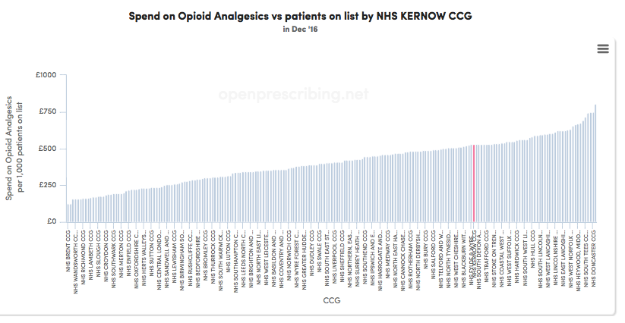

We want to reduce this because, in the long run, it should benefit patients’ clinical care quality, primary and secondary care activity and the prescribing budget. We have contributed to an iatrogenic public health disaster and we need to reverse that.

Why bother?

- The CCG will financially incentivise you to do this work – talk to your prescribing teams
- It’s GOOD MEDICINE
- It’s a great CPD opportunity for a worthwhile appraisal project
- Reducing opioid prescribing in primary care is an evidence free zone – we want you to contribute to furthering our knowledge and understanding of what is and what isn’t possible.

Your work will not only help your own patients but also a much wider audience for which we thank you.

There are three groups of patients who we believe can be “demedicalised” most easily:

- patients on more than 120mg of Oral Morphine Equivalent (OME) per day
- patients who are motivated to self-deprescribe
- non-prescribing in the opioid naïve

As stated, we cannot advise from the literature methods to use in your surgery to identify, contact, meet and successfully reduce prescribing to these groups. We want you to use your intuition and skills and importantly FEED BACK TO US WHAT YOU DID AND THE RESULTS so we can share and broaden our knowledge.

We suggest prioritising group 1 because
- calculating oral morphine equivalents per day is simple – Google search “opioid conversion”
- risks are definitely more than benefits over 120mg OME per day
- you have already identified these patients in a recent county wide audit

We would be very grateful if you could outline what you did and how you did it and email a summary to jameshuddy@nhs.net

Good luck

FURTHER THOUGHTS:

- Patients on more than 120mg of Oral Morphine Equivalent (OME) per day

Different opioids have different potencies so, for example, a 25mcg per hour patch of fentanyl is equivalent to about 100mg of oral morphine per day – for a comprehensive conversion chart just Google search “opioid conversion chart”

As the “opioids aware” website says: “the risk of harm increases substantially at doses above OME 120mg/day but there is no increased benefit”

Therefore, this is harmful and dangerous prescribing.
It is your responsibility to wean these patients down to 120mg OME per day.

Hopefully patients will accept this discussion however some may resist. We believe that it is both clinically and ethically defensible practice to make this decision unilaterally if needs be. Dose reductions below this “national speed limit” of 120mg OME per day should be more of a shared decision.

See the “how to wean opioids” section

AUDIT OPPORTUNITY

Search for your patients who are over 120mg OME per day and review their case. If the prescribing is for chronic pain then inform them that doses need to reduce to this limit. Be firm. Point them to the patient information section for information. Follow the weaning opioid algorithm.

You have probably partially done this work – in 2016 the prescribing team incentivised an audit searching for this exact patient group.

- Patients who are self motivated to wean down or cease their analgesic medication

Painkillers are getting a bad press recently: there have been documentaries nationally (e.g. “The doctor who gave up drugs” BBC) and locally “Inside Out” recently featured one of our team Dr Adrian Flynn (liaison psychiatry) and a Newquay GP Dr Tamsyn Anderson who presented two cases of iatrogenic opioid harm and the benefits of dose reduction.
Even the Daily Mail is on-side! They have run multiple articles on the lack of benefit and the risk of harm of commonly used analgesics in the UK.

Therefore we feel that the time is ripe to use this wave of media attention to invite patients to reduce or stop their medications.

Anyway, drug holidays are an important part of ensuring opioid prescribing is benefitting patients’ FUNCTION (not just their pain scores).

AUDIT SUGGESTION

Contact all patients on painkillers and signpost them to the “information for patients” section , for example – a prefabricated message on script labels.

Let them see the alternatives. Help them plan a weaning regimen. You might be surprised how much uptake there is.

- Anticipating and prevention of future problems in the opioid naïve

GPs have good clinical instinct because we understand people and we know our local area. You may be able to anticipate when your doctor patient relationship will run into a conflict regarding opioid dosing.

We have written an OPIOID MANAGEMENT PLAN AND CONTRACT. You might see it filled in by hospital doctors.

We suggest you use this if you anticipate future problems and you want mitigate risk. It will empower you as a prescriber.

AUDIT SUGGESTION

Monitor who you use the contract with. Watch how many of these patients end up on long term opioids and at what doses.

THE ROLE OF THE PAIN CLINIC

Audio version here

We all know that an app isn’t going to help someone who is in severe pain, unable to get around, scared, lonely, sleepless, iatrogenically dependent on opioids and then their house gets repossessed.

There are many patients out there in pain who can be helped by self management with some GP input but the patients with heavier burdens who are less able to break free from their pain will need more intense intervention.

In a nutshell, the pain clinic is a multidisciplinary team of anaesthetic doctors, psychologists, specialist nurses and physiotherapists who provide a model of pain management just like that described above but we tend to reserve this precious resource for patients who have more complex biopsychosocial problems.

Factors that may make you consider referral:

- Simple approaches have been tried and have not improved matters adequately
- Complex pain conditions, or pain conditions in complex patients
- Pain conditions that are amenable to pain-clinic interventional management (see website for some guidance); http://www.royalcornwall.nhs.uk/services/pain/
- Patients for whom attending a Pain Management Program may be helpful

If you are not clear that referral is appropriate, please make this clear in your “referral” letter, or contact the pain team by email (keith.mitchell4@nhs.net) or telephone 01872 252792

Pain management programmes
A pain management programme helps patients to self-manage their pain problems. It teaches patients how to reverse many of the negative changes that affect their life and that of their family. It shows patients how to acquire the necessary skills and knowledge to reduce disability, become more physically active, and improve quality of life.
In broad terms, a programme includes:

- Learning how to exercise in a way that is best for people with chronic pain. This means building up fitness and activity levels on a very gentle and gradual basis so that you can do a little every day without suffering for it later.
- Learning how to pace activities so that you stop doing too much on a good day but almost nothing on a bad day.
- Learning the skills of relaxation to reduce physical and emotional tension and help with flare-ups and sleep problems.
- Learning about how chronic pain differs from acute pain and developing an understanding of how the body works, particularly in the context of a ‘chronic pain syndrome’.
- Looking at how thoughts and feelings affect the way you deal with a long-term pain problem and learning how to modify unhelpful thoughts in order to change the ways you deal with their pain problem.
- Learning how to plan out and set short-term and long-term goals on a step by step basis in order to improve many aspects of day-to-day life.
- Learning how to deal with temporary set-backs and use pain management principles in the years ahead.

REFERENCES

The major sources of information for what we’ve written are:

- Opioids aware subsection of the Faculty of Pain Medicine, which has detailed information for clinicians and patients for all opioid matters
http://www.rcoa.ac.uk/faculty-of-pain-medicine/opioids-aware

- Sheffield Persistent Pain is a website constructed by the multidisciplinary team in Sheffield which has kindly supplied a lot of the video clips we’ve used. There are lots of forward links along the same lines
https://www.sheffieldpersistentpain.com/

- The Pain Community Centre is a free learning resource for any healthcare professional, seeking evidence based information and education on pain and its management. You can study to an advanced level with this resource.
http://www.paincommunitycentre.org/

- SIGN GUIDELINE 136 – THE MANAGEMENT OF CHRONIC PAIN
http://www.sign.ac.uk/guidelines/fulltext/136/

There are no conflicts of interest to declare in this publication

AUTHORSHIP

This document is a collaborative work between
- General practice (Dr Jim Huddy GP Perranporth and CCG clinical lead for chronic pain)
- Pain medicine (Dr Keith Mitchell, Sarah Medlicott, Barbara Sharp)
- Liaison psychiatry (Dr Adrian Flynn)
- Gastroenterology (Dr Paul Fortun)

Published June 2017

We welcome comments and feedback to jameshuddy@nhs.net

Or to your prescribing team

A HARROWING CASE REPORT

Audio version here

